CI/CD Pipeline for Ruby on Rails Legal Application
using Docker & Kubernetes
Course Name: DevOps
Institution Name: Medicaps University – Datagami Skill Based Course
Student Name(s) & Enrolment Number(s):
Sr no | Student Name | Enrolment Number
01 | Animesh Parashar | EN22CS301128
02 | Anirudh Singh Rathore | EN22CS301130
03 | Anshika Parsai | EN22CS301151
04 | Anshul Goyal | EN22CS301157
05 | Anushka Mukati | EN22CS301181

Group Name:02D6
Project Number: DO-13
Industry Mentor Name:
University Mentor Name: Prof. Akshay Saxena
Academic Year: 2025-2026
TABLE OF CONTENTS
S.NO. | TOPICS
1 | INTRODUCTION | 1.1 SCOPE OF THE DOCUMENT
 |  | 1.2 INTENDED AUDIENCE
 |  | 1.3 SYSTEM OVERVIEW
2 | SYSTEM DESIGN | 2.1 APPLICATION DESIGN
 |  | 2.2 PROCESS FLOW
 |  | 2.3 INFORMATION FLOW
 |  | 2.4 COMPONENTS DESIGN
 |  | 2.5 KEY DESIGN CONSIDERATIONS
 |  | 2.6 API CATALOGUE
3. | DATA DESIGN | 3.1 DATA MODEL
 |  | 3.2 DATA ACCESS MECHANISM
 |  | 3.3 DATA RETENTION POLICIES
 |  | 3.4 DATA MIGRATION
4. | INTERFACES
5. | STATE AND SESSION MANAGEMENT
6. | CACHING
7. | FUNCTIONAL  REQUIREMENTS | 7.1 AUTOMATED BUILD AND  TESTING PROCESS
7.2 APPLICATION
CONTAINERIZATION USING DOCKER
 |  | 7.3 DEPLOYMENT ON AWS EC2
 |  | 7.4 MONITORING AND LOGGING
8. | NON-FUNCTIONAL REQUIREMENTS | 8.1 SECURITY

 |  | 8.2 PERFORMANCE
 |  | 8.3 SCALABILITY
 |  | 8.4 RELIABILITY
9 . | REFERENCES

1 . INTRODUCTION
In modern software development, delivering high-quality applications quickly and reliably is very important. Traditional deployment methods are manual, time-consuming, and prone to errors. To overcome these challenges, DevOps practices such as Continuous Integration (CI) and Continuous Deployment (CD) are widely used.
This project focuses on designing a CI/CD pipeline for a Ruby on Rails Legal Application. The system automates the entire software development lifecycle, including building, testing, containerization, and deployment. By using tools like Git, GitHub, Jenkins/GitHub Actions, Docker, and Kubernetes, the pipeline ensures faster and more reliable delivery of the application.
In this system, developers push code to a GitHub repository, which automatically triggers the CI/CD pipeline. The pipeline builds the application, runs automated tests, and creates a Docker image. This image is then deployed using Kubernetes, ensuring scalability and consistency across environments.
The main objective of this project is to create an automated, efficient, and reliable deployment process that reduces manual effort, improves code quality, and ensures smooth application delivery.

1.1 SCOPE OF THE DOCUMENT
This document presents the High-Level Design (HLD) of the CI/CD pipeline for the Ruby on Rails Legal Application. It provides an overview of the system architecture, workflow, and integration of various DevOps tools.
The scope of this document includes:
- Description of system components and their interactions
- Explanation of CI/CD pipeline workflow
- Overview of deployment strategy using Docker and Kubernetes
- Identification of functional and non-functional requirements
However, this document does not cover low-level implementation details such as source code, configuration scripts, or specific command-level instructions.

1.2 INTENDED AUDIENCE
This document is intended for multiple stakeholders involved in the development and deployment of the system:
- Developers – To understand how their code integrates into the CI/CD pipeline and how deployment is automated.
- DevOps Engineers – To design, implement, and maintain the CI/CD pipeline and infrastructure.
- System Administrators – To manage deployment environments, monitor system performance, and ensure availability.
- Project Evaluators – To assess the feasibility, scalability, and effectiveness of the system design.

1.3 SYSTEM OVERVIEW
The system automates the software delivery lifecycle of a Ruby on Rails Legal Application using a CI/CD pipeline. Developers push code to a GitHub repository, which triggers the pipeline using Jenkins or GitHub Actions.
The pipeline builds the application, runs automated tests, and creates a Docker image. This image is stored in a container registry and deployed using Kubernetes.
Kubernetes manages the application by handling deployment, scaling, and availability. The final application is then accessible to users.
This automated process ensures faster development, reliable deployment, and consistency across different environments.

2 . SYSTEM DESIGN
The system design of the CI/CD pipeline for the Ruby on Rails Legal Application is based on a modular and automated architecture. It integrates various DevOps tools to ensure efficient software development, testing, and deployment.
The application is containerized using Docker and deployed using Kubernetes, which provides scalability, reliability, and consistency across different environments. The system follows an automated pipeline approach where each stage is executed without manual intervention.

2.1 APPLICATION DESIGN
The application is developed using Ruby on Rails, following the Model-View-Controller (MVC) architecture.
- Model manages database and data logic
- View handles the user interface
- Controller processes user requests and business logic
The application includes modules such as user authentication, case management, and document handling.
It is containerized using Docker to ensure consistency across environments and deployed using Kubernetes, which provides scalability and high availability.
.

2.2 PROCESS FLOW
The CI/CD pipeline follows an automated process to build, test, and deploy the application:
- Developer writes code and pushes it to the GitHub repository
- CI/CD pipeline is automatically triggered
- The application is built and dependencies are installed
- Automated tests are executed to ensure code quality
- A Docker image is created using a Dockerfile
- The image is pushed to a container registry
- Kubernetes pulls the image and deploys the application
- The application becomes available to users

2.3 INFORMATION FLOW
The information flow in the CI/CD system represents how data and code move through different components during the software delivery process.
- The process begins with the developer, who writes code and pushes it to the GitHub repository.
- The code is stored in GitHub, which acts as the central version control system.
- Once the code is pushed, the CI/CD pipeline is automatically triggered.
- The pipeline processes the code by building the application and running automated tests.
- After successful testing, a Docker image is created and packaged.
- The Docker image is then pushed to a Docker registry for storage.
- The Kubernetes cluster pulls the image from the registry and deploys it as containers.
- Finally, the deployed application is made available to end users for access

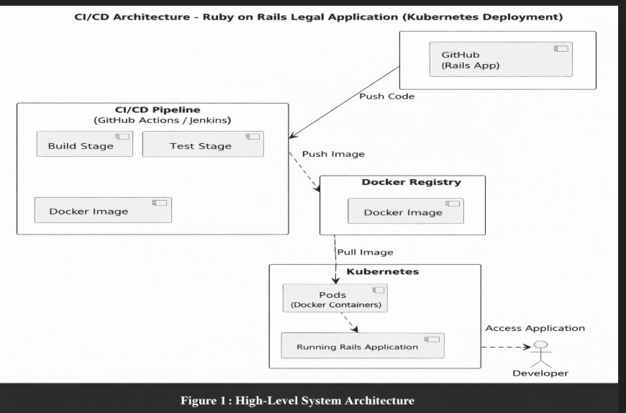

2.4 COMPONENTS DESIGN
• GitHub – Stores source code and triggers the pipeline
• CI/CD Tool (Jenkins/GitHub Actions) – Automates build and testing
• Docker – Creates application containers
• Docker Registry – Stores Docker images
• Kubernetes – Deploys and manages containers
• Monitoring Tools – Track performance and logs

2.5 KEY DESIGN CONSIDERATIONS

Scalability – The system should handle increasing workload using Kubernetes auto-scaling.

Reliability – Automated testing ensures stable and error-free deployments.

Security – Secure access using authentication, tokens, and environment variables.

Portability – Docker containers ensure the application runs consistently across environments.

Automation – CI/CD pipeline reduces manual effort and speeds up deployment.

2.6 API CATALOGUE
• Kubernetes API – Manages deployment and scaling
• CI/CD API – Controls pipeline execution
• Docker API – Builds and manages images
• GitHub API – Handles code integration and triggers

3 . DATA DESIGN
The data design of the CI/CD pipeline focuses on managing, storing, and tracking information across different stages of the software delivery lifecycle. It ensures that data related to source code, pipeline execution, Docker images, and deployments is handled efficiently and securely.
The system maintains structured data to support automation, monitoring, and rollback mechanisms. Proper data design helps in improving traceability, debugging, and overall system reliability.

3.1 DATA MODEL
The system is based on a logical data model consisting of the following key entities:
- Repository
Stores the source code of the application along with version history. It tracks all code changes made by developers.
- Pipeline
Represents each execution of the CI/CD pipeline. It stores details such as build status, execution time, logs, and test results.
- Docker
Contains the packaged application along with its dependencies. Each image is versioned using tags for easy identification and rollback.
- Deployment
Represents the running application in the Kubernetes cluster. It stores information about container status, replicas, and environment configuration.
These entities are interconnected and represent different stages of the CI/CD workflow.

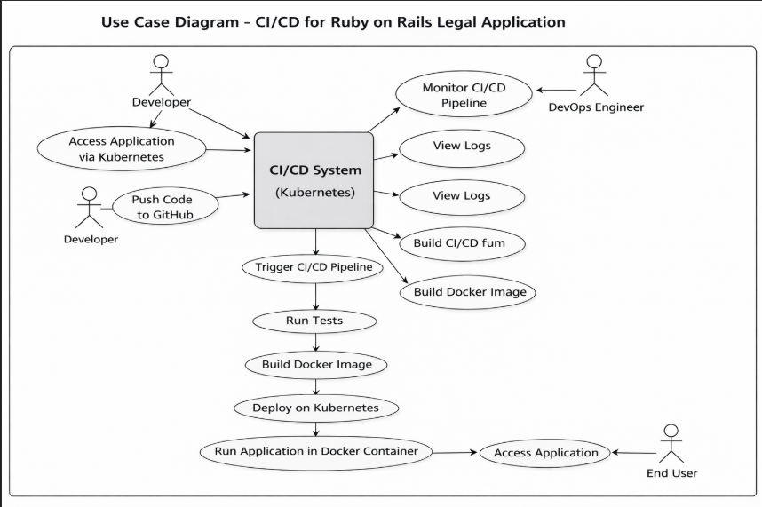
Figure 2 :Use Case Diagram

3.2 DATA ACCESS MECHANISM
The system ensures secure and controlled access to data using the following mechanisms:
- Authentication
Access to GitHub is managed using personal access tokens. Docker registry access requires secure credentials, and Kubernetes access is controlled through secure login mechanisms.
- Authorization
Role-Based Access Control (RBAC) is implemented in Kubernetes to ensure that only authorized users can perform specific actions such as deployment or scaling.
- Secure
Data transfer between components is secured using HTTPS and encrypted channels to prevent unauthorized access.

3.3 DATA RETENTION POLICIES
To maintain system efficiency and support debugging, the following data retention policies are implemented:
- Pipeline : Logs generated during build, test, and deployment stages are stored for a specific duration. These logs help in identifying issues and debugging failures.
- Docker : Docker images are stored with version tags. Older versions are retained for rollback purposes, while unused images may be periodically removed to save storage.
- Deployment : Information about previous deployments is maintained to track changes and ensure traceability.

3.4 DATA MIGRATION
The system supports smooth data migration and version updates through container-based deployment:
- Version
Each new version of the application is packaged as a new Docker image and deployed without affecting the existing system.
- Rolling
Kubernetes performs rolling updates, ensuring zero downtime during deployment.
- Rollback
In case of failure, the system can revert to a previous stable version using stored Docker images.

4 . INTERFACES
The system provides multiple interfaces to enable interaction between users and system components, as well as communication between different tools in the CI/CD pipeline. These interfaces ensure smooth operation, monitoring, and management of the application.

4.1 User Interface

The user interface allows users to interact with different tools through graphical dashboards:

GitHub Interface
Used for managing source code, repositories, and version control.

CI/CD Dashboard (Jenkins/GitHub Actions)
Provides visibility of pipeline stages such as build, testing, and deployment.

Kubernetes Dashboard
Used to monitor container deployment, scaling, and cluster status.

These interfaces provide easy access and control for developers and administrators.

4.2 Command Line Interface

The command line interface provides flexibility and control for advanced operations:

Git CLI
Used for version control operations like commit, push, and pull.

Docker CLI
Used to build, run, and manage containers.

kubectl (Kubernetes CLI)
Used to deploy, manage, and monitor Kubernetes resources.

CLI tools allow faster execution of commands and automation through scripts.

5. STATE AND SESSION MANAGEMENT
• Application state is maintained within containers
• User sessions are handled securely
• Kubernetes ensures availability by restarting failed containers
This ensures system stability and availability.

6.CACHING
1. Docker Layer Caching – Speeds up image building by reusing existing layers
2. Dependency Caching – Reduces time for installing libraries and packages
3. Pipeline Caching – Stores build artifacts to improve CI/CD performance

7 . FUNCTIONAL REQUIREMENTS
The functional requirements define the core features and operations that the CI/CD pipeline system must perform to automate the development, testing, and deployment of the Ruby on Rails Legal Application.

7.1 AUTOMATED BUILD AND TESTING PROCESS
The system must automatically build and test the application whenever new code is pushed to the repository.
- Trigger the CI/CD pipeline on every commit or pull request
- Fetch the latest source code from the repository
- Install all required dependencies and libraries
- Compile and build the application
- Execute unit tests and integration tests
- Generate test reports and logs
- Stop the pipeline if any test fails
This ensures that only high-quality and error-free code proceeds to the next stage.

7.2 APPLICATION CONTAINERIZATION USING DOCKER
The system must automatically build and test the application whenever new code is pushed to the repository.
- Trigger the CI/CD pipeline on every commit or pull request
- Fetch the latest source code from the repository
- Install all required dependencies and libraries
- Compile and build the application
- Execute unit tests and integration tests
- Generate test reports and logs
- Stop the pipeline if any test fails
This ensures that only high-quality and error-free code proceeds to the next stage.

7.3 DEPLOYMENT
The system must automatically deploy the application using Kubernetes after successful build and testing.
- Pull Docker images from the registry
- Deploy containers as Kubernetes pods
- Manage application services and networking
- Support horizontal scaling based on load
- Perform rolling updates for new versions
- Enable rollback to previous versions if needed

7.4 MONITORING AND LOGGING

The system must provide monitoring and logging capabilities for tracking performance and debugging.

Monitor application health and performance

Track pipeline execution status

Collect logs from build, test, and deployment stages

Provide alerts for failures or issues

Enable analysis of logs for troubleshooting

This helps maintain system reliability and quickly resolve issues.

8. NON-FUNCTIONAL REQUIREMENTS
Non-functional requirements define the quality attributes of the system. They ensure that the CI/CD pipeline is secure, efficient, scalable, and reliable while handling the deployment of the Ruby on Rails Legal Application.

8.1 SECURITY
- Use secure authentication mechanisms such as tokens and SSH keys
- Store sensitive data (passwords, API keys) using environment variables or secret managers
- Implement Role-Based Access Control (RBAC) in Kubernetes
- Ensure secure communication using HTTPS
- Regularly update dependencies to avoid vulnerabilities

8.2 PERFORMANCE
- . Optimize build time using caching mechanisms
- . Reduce deployment time using containerization
- . Ensure minimal downtime during updates
- . Efficient resource utilization in Kubernetes

8.3 SCALABILITY
- . Support horizontal scaling using Kubernetes
- . Automatically scale containers based on traffic
- . Load balancing to distribute requests evenly
- . Handle multiple pipeline executions simultaneously

8.4 RELIABILITY
- . Ensure high availability using Kubernetes clusters
- . Automatically restart failed containers
- . Support rollback to previous stable versions
- . Continuous monitoring to detect failures

9 . REFERENCES

- Git Documentation. Git SCM. Available at: https://git-scm.com/docs
- Docker Documentation. Docker Official Docs. Available at: https://docs.docker.com
- Kubernetes Documentation. Kubernetes Official Site. Available at: https://kubernetes.io/docs
- Jenkins Documentation. Jenkins User Handbook. Available at: https://www.jenkins.io/doc
- GitHub Actions Documentation. GitHub Docs. Available at: https://docs.github.com/actions
- Ruby on Rails Guides. Official Rails Documentation. Available at: https://guides.rubyonrails.org
- DevOps Practices. AWS DevOps Resources. Available at: https://aws.amazon.com/devops/

10. GITHUB
https://github.com/Mohit150105/Energy-App

